List of companies name
- InterGlobe Enterprises (IGE)
- Volocopter
A pioneer in urban air mobility (UAM) that aims to provide affordable air taxi services to cities worldwide
- 
Lilium
A Munich-based startup that is developing an on-demand air taxi service
- 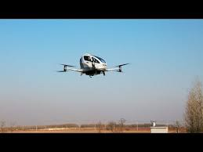
EHang 184
An Autonomous Aerial Vehicle (AAV) developed by Chinese entrepreneurs that is intended for short and medium distance commuting
- 
Archer Aviation
A US company that makes the Maker, a fully electric flying taxi that can carry two passengers and fly up to 240 kmph
- 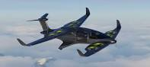
Ascendance Flight Technologies
A company that designs and builds air mobility vehicles using their patented hybrid VTOL technology
- 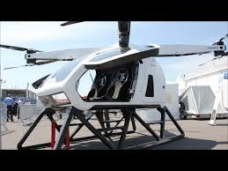
SureFly
A VTOL developed by Workhorse that is intended for commercial operators and consumers
- BAE Systems
A company that supplies electric propulsion systems for ground vehicles and flight controls for military aircraft
- 
Beta Technologies
A company that is a leader in advanced air mobility vehicles, also known as air taxis

